|  |  |  |  |  |
| --- | --- | --- | --- | --- |
| Group | Functional Group | Ending | Example | Comments |
| alkane | Nil | -ane | propane | * single bonds only |
| alkene | double bonded carbons | -ene | propene | * double bond between hydrogens * positional isomers possible |
| alcohol | hydroxyl group | -ol | propanol | * H from alkane replaced by –OH * positional isomers possible * subdivided into primary, secondary and tertiary* |
| aldehydes and ketones | carbonyl group | -al (aldehyde)  -one (ketone) | propanal  propanone | * H from alkane replaced by double-bonded O * If at the chain end, it is an aldehyde if not, it is ketone / positional isomers possible for ketones. |
| carboxylic acid | carboxyl group | -oic acid | propanoic acid | * End H from alkane replaced by -COOH |
| Amines  (primary) | Amino group | -amine | propanamine | * H from alkane replaced by –NH2 * positional isomers possible |
| Derived from carboxylic acids | | | |  |
| amides | Amide group | -amide | propanamide | * OH from carboxylic acid replaced by NH2 |
| ester | Ester group | -yl –oate  -alkyl - acid | propyl propanoate | H from a carboxylic acid replaced by alkyl group |

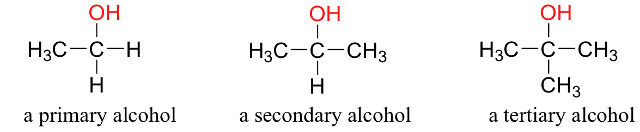*Alcohols

Primary: C-OH attached to 1 other carbon

Secondary: C-OH attached to 2 other carbons

Tertiary: C-OH attached to 3 other carbons